Measuring Health Status > Measures of Epidemiology:

**M**ellow **M**usic **I**nfluences **L**ife

(mortality, morbidity, infant mortality, life expectancy)

Identifying Priority Health Issues:

**P**assive **P**enguins **P**rolong **C**old **S**naps

(priority population groups, prevalence of condition, potential for early intervention/prevention, costs to the individual/community, social justice principles)

**CORE 1:**

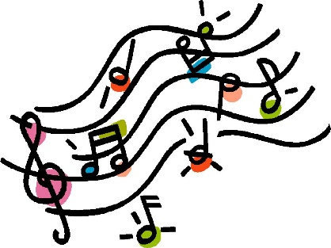

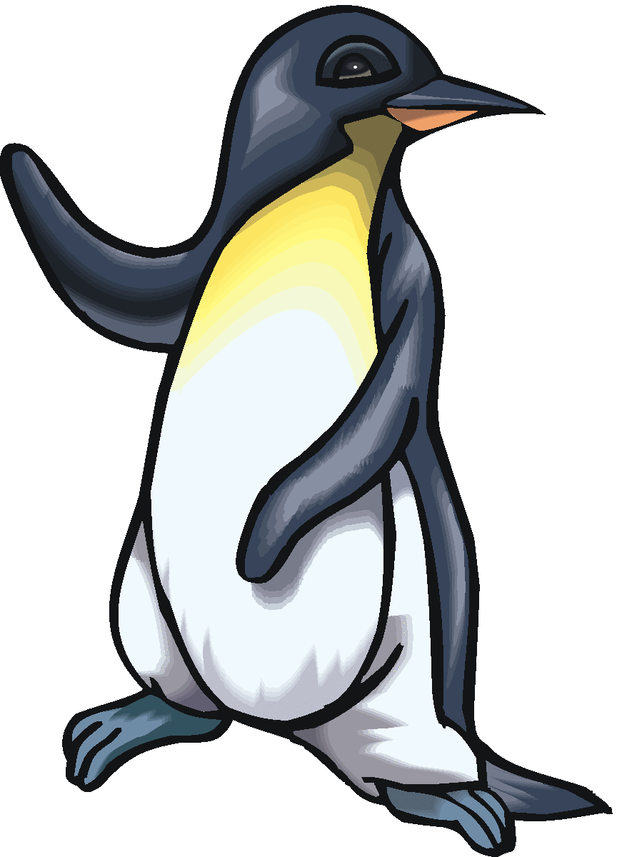

Social Justice Principles:

**D**ogs **E**at **S**ausages

(diversity, equity, supportive environments)

High Levels of Preventable Chronic Disease, Injury and Mental Health Problems:

**C**ivil **C**ows **D**on’t **M**oo **I**n **R**ivers

(CVD, cancer, diabetes, mental health conditions, injuries, respiratory diseases)

Groups Experiencing Health Inequities:

**P**aradise **T**reats **A**ll **P**eople the **S**ame, **O**bviously

(people with disabilities, the elderly, ATSI, people in rural/remote areas, socioeconomically disadvantaged people, overseas-born people)

A Growing and Ageing Population:

**…D**elight **I**n **H**earing **A**ids

(demands for health services and workforce shortages, increased population living with chronic disease and disability, healthy ageing, availability of carers and volunteer )

Complementary and Alternative Health Care Approaches:

**A**nteaters **A**lleviate **I**tchy **N**oses with **C**runchy **H**erb **M**edicines

(aromatherapy, acupuncture, iridology, naturopathy, chiropractic services, herbalism, massage)

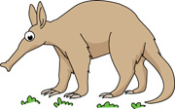

Ottawa Charter:

**D**ead **C**ats **S**mell **R**eally **B**ad (develop personal skills, create supportive environments, strengthen community action, reorient health services, build healthy public policy)

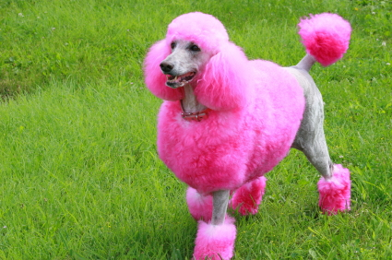

Supplementation:

**Peckish Crows Consume Veal**

(protein, caffeine, creatine products, vitamins/minerals)

Assessment of Skill and Performance > Characteristics of Skilled Performers:

**T**ai-kwon-do **A**rtists **K**ick **C**onfidently

(technique, accuracy, kinaesthetic sense, consistency)

Characteristics of the Learner:

**P**roper **A**thletes **P**ractice **H**urdles **C**almly

(personality, ability, prior experience, heredity, confidence)

Recovery Strategies:

**P**ink **P**uppies **N**eed **T**herapy

(physiological, psychological, neural, tissue damage)

The Learning Environment:

**N**ever **F**eed **P**igs **T**ruffles

(nature of the skill, feedback, practice method, the performance elements)

Assessment of Skill and Performance:

**P**eople **C**heer for **O**utstanding **V**aulters

(personal/prescribed judging criteria, characteristics of skilled performers, objective/subjective performance measures, validity/reliability of tests)

Psychological Strategies to Enhance Motivation and Manage Anxiety:

**M**oroccan **G**azelles **R**un **C**almly

(mental rehearsal, goal-setting, relaxation techniques, concentration skills)

Physiological Adaptions in Response to Training:

**R**ed **S**trawberries **C**reate **L**ovely **O**dours **M**ay **H**arvest **E**venings

(resting heart rate, stroke volume, cardiac output, lung capacity, oxygen uptake, muscle hypertrophy, haemoglobin level, effect on slow twitch/fast twitch muscle fibres)

Principles of Training:

**RSVP** **T**o **W**eddings

(reversibility, specificity, variety, progressive overload, training thresholds, warm up/cool down)

**CORE 2:**

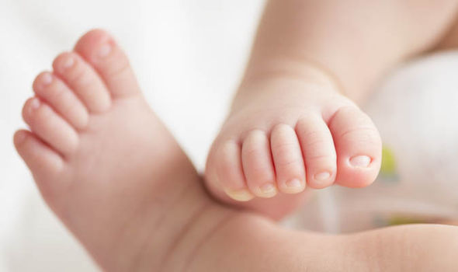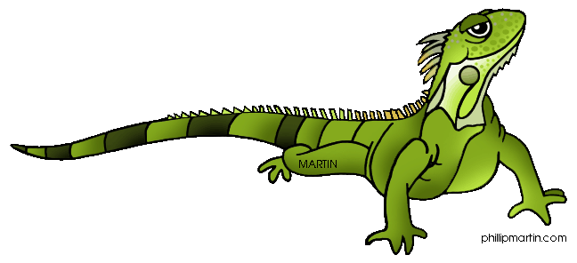

**Sports Medicine 1:**

**TOTAPS**

(talk, observe, touch, active movement, passive movement, skills test)

Adult and Aged Athletes:

**H**eroes **F**eel **F**ragile

(heart conditions, flexibility/joint mobility, fractures/bone density)

**RICER**(rest, ice, compression, elevation, referral)

Female Athletes:

**P**regnant **I**guanas **E**at **B**ananas

(pregnancy, iron deficiency, eating disorders, bone density)

Children and Young Athletes:

**M**ost **T**eenagers **O**bject **R**ules

(medical conditions, thermoregulation, overuse injuries, resistance training appropriateness)

**Sports Medicine 2:**

Sports Policy and the Sports Environment:

**M**ost **M**arathon **R**unners **P**romote **S**afety

(modified rules for children, matching of opponents, rules of sports/activities, protective equipment use, safe grounds, facilities and equipment)

Physical Preparation:

**P**reparing **S**trenuously **P**roduces **W**inners

(pre-screening, skill and technique, physical fitness, warm-up/stretching/cool-down)

Environmental Considerations > Climatic Conditions:

**A**rchery **T**eams **P**erform **W**orse in **H**umidity and **R**ain

(altitude, temperature, pollution, wind, humidity, rain)



Environmental Considerations:

**A**nts **F**eel **C**old **T**oo

(acclimatisation, fluid intake, temperature regulation, climatic conditions)

Taping and Bandaging:

**B**and-aids **P**roduce **I**tchiness

(bandaging for immediate treatment, preventative taping, taping for **I**solation of injury)

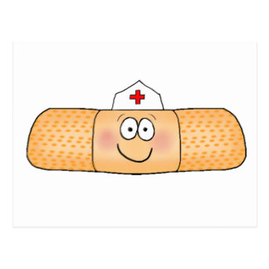

Environmental Considerations > Temperature Regulation

**C**ooking **E**levates **R**oom **C**elsius

(conduction, evaporation, radiation, convection)

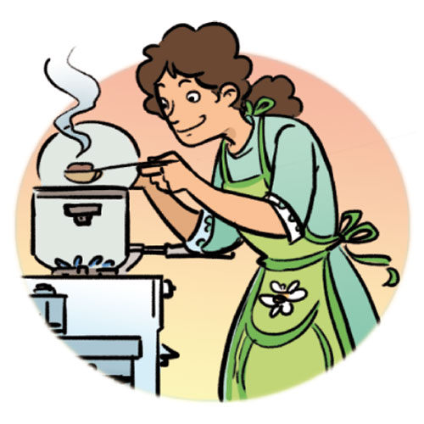

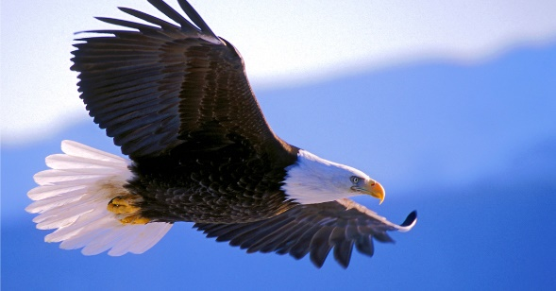

Rehabilitation Procedures:

**G**reat **T**reatment **H**eals **P**romptly

(graduated exercise, training, heat/cold use, progressive mobilisation)

Return to Play:

**E**agles **S**oar **M**ildly, **I**n **P**otential **R**isks

(ethical considerations, specific warm-up procedures, monitoring progress, indicators of readiness, psychological readiness, return to play policies and procedures)

Return to Play > Indicators of Readiness

**M**ighty **E**lite **P**ara-athletes **B**egin **S**lowly

(mobility, elasticity, pain-free, balance, strength)



Initial Planning Considerations:

**P**arties **S**tart **C**haos   
(performance/fitness needs, schedule of events/competitions and climate/season)

**Improving Performance:**

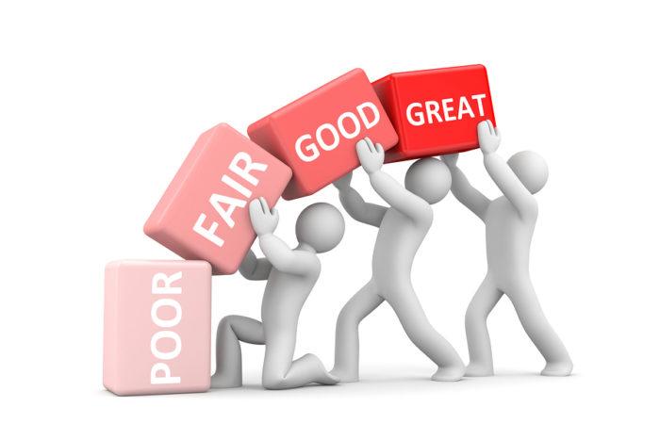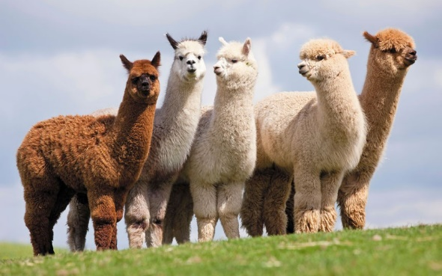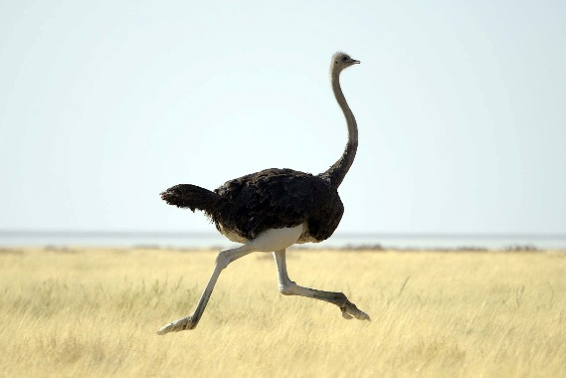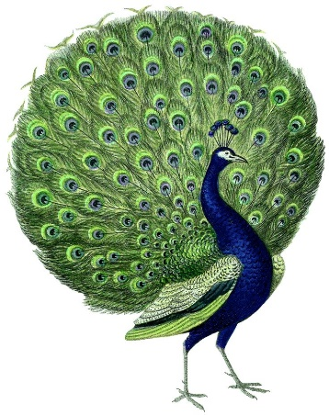

Elements to be Considered when Designing a Training Session:

**H**ealthy **O**striches **W**ork **C**onductively **E**ach **S**ession

(health and safety, overview, warm-up/cool-down, conditioning, evaluation, skill instruction/practice)



Planning a Training Year:

**T**raining **P**eacocks **S**ounds **P**retty **S**trenuous

(tapering, peaking, sub-phases, phases of competition, sport-specific sub-phases)

Planning to Avoid Overtraining:

**A**void **P**erforming **P**oorly!

(amount/intensity of training, physiological factors, psychological factors)

Use of Drugs:

**D**aft **M**agic **A**lpacas **B**ehave **S**illily

(dangers of use, masking drugs, aerobic drugs, benefits/limitations of testing, strength drugs)